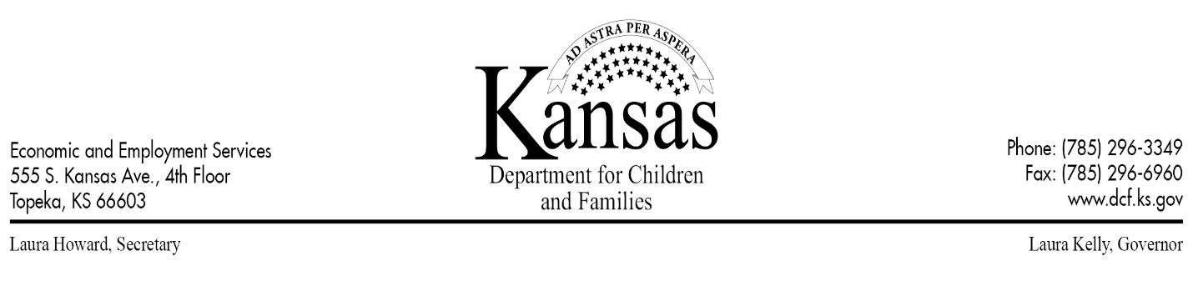
M E M O R A N D U M
TO: EES Program Administrators
FROM: Carla Whiteside-Hicks, PhD
DATE: 05/01/2023
SUBJECT: Implementation Instructions - KEESM Revision 110
This memo provides implementation instructions and information for the following May 1, 2023 policy changes in the Kansas Economic and Employment Services Manual (KEESM).

FOOD ASSISTANCE
- Deceased Data Match - During the certification period, information regarding household circumstances that requires verification to determine a household’s continued eligibility for Food Assistance may be received. Unclear information can be determined verified or verified, but still requiring additional information before action can be taken. Information received from the Deceased Data Match is considered unclear information and additional information is needed to verify accuracy.
When unclear information from the Deceased Data Match is received, staff must generate a notice of action informing the household of the match results. The notice must clearly detail the information the household must provide and the action DCF will take if the household fails to respond or provide the information within 10 days. If a household fails or refuses to respond to the notice within 10 days, the Date of Death (DOD) indicated in the Deceased Data Match can be used to update the Individual Demographics page. Social Security Interface DOD and/or an obituary can also be used to verify DOD.

Deceased Data Match Process:
- Add a verification record
  - On the Verification Detail page, select Other as the Verification Type, and copy and paste the following text into the Description text box: Data Match indicates a household member has passed away. Please contact DCF.
  - On the Verification Detail page, generate a V000.
- If the household fails or refuses to respond to the RFI within 10 days, take the following action:
  - Add DOD for the individual and run EDBC allowing for timely and adequate notice of a negative change.
    - For one-person households, delete the NOA.
- If the agency receives information from the household, authorized representative or guardian confirming the DOD, adequate notice only is needed for the reduction or termination of benefits (KEESM 1432)
  - Add DOD for the individual and run EDBC allowing for adequate notice only of a negative change.
    - For one-person households, delete the NOA.
KEESM Home | EES Home |
Page Last Updated: 04/06/2023 5:00 pm

