02-25

Kelley Blue Book User Instructions

The Kelley Blue Book is an on-line resource available on the Internet to establish vehicle resource values. This same process may be used as a pricing guideline in purchasing cars for work programs participants.

1. Go to <http://www.kbb.com/whats-my-car-worth/>. Add this to your Favorites list if you want to have faster access to the site. This site gives the option of finding trade-in and private-party values. For our resource purposes, we are only looking at trade-in of vehicles in fair condition.
2. The first step on this screen is to click on the **Year** drop-down arrow to select the model year you are looking for.

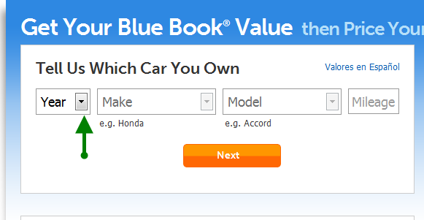

1. After selecting the year, the **Make** drop-down list is accessible. Click on the drop-down arrow and select the appropriate make.

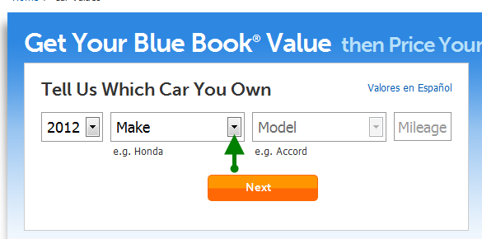

1. After selecting the **Make**, the **Model** drop-down list is accessible. Click on the drop-down arrow and select the appropriate model of the vehicle.

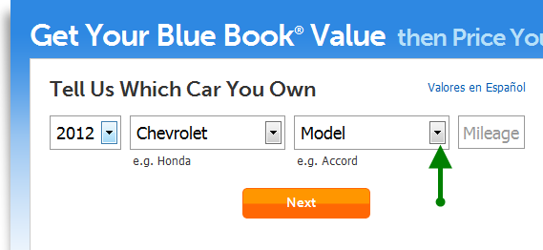

1. After selecting the **Model** click in the Mileage box and enter a mileage figure (“Mileage” remains gray, but numbers typed will be accepted).

**Note:** To calculate the mileage, a standard formula of multiplying the age of the vehicle times 15,000 miles per year is to be used. Count the year of the vehicle as the first year and include the current year in the vehicle age or subtract the current year from the model year and add 1. Example: 2015 – 2012 = 3 + 1 = 4.

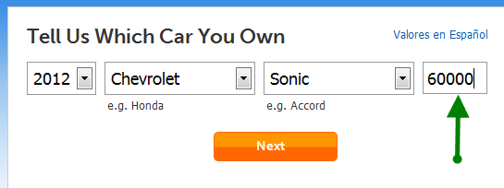

Click **Next**.

1. The next screen has a box for the zip code. Entry of a zip code is required, as vehicle values may vary in different parts of the country. Enter the zip code for the client’s home address.

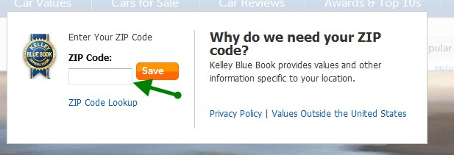

Click **Save**.

After you enter the zip code, it will remain in the system for subsequent searches during the same browsing session.

**Note:** The zip code will remain until the browser is closed. It is recommended to close the browser after determining the resource value.

1. If the vehicle has more than one category, the next screen will ask you to select a category. Select the category that is designated as the lowest priced if you do not have information about which specific one it is.

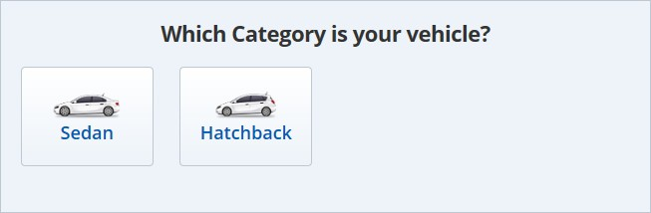

1. After selecting the vehicle category, the “Which Style is your vehicle?” section opens below. Always select the first style (Lowest priced) in the list unless you have specific information indicating it is something different.

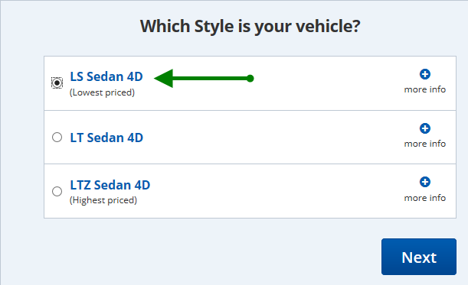

Click **Next**.

1. The next screen is where options are selected. Always select **Priced with standard equipment**

unless you have specific information indicating it is otherwise equipped.

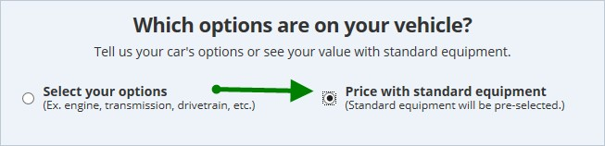

1. Scroll down to the “What is your vehicle color?” Select **White** if available or other neutral color if white is not available, unless the actual color is known.

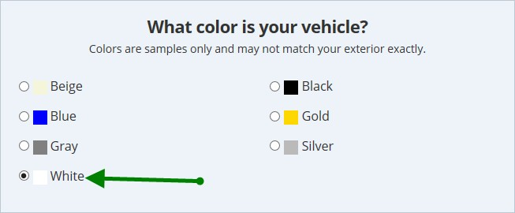

1. 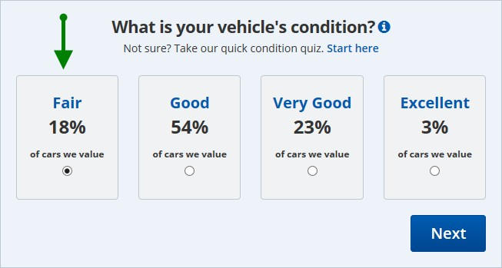Scroll further down to “What is your vehicles condition?” section and select **Fair**. Click **Next**.

Click **Next**.

1. 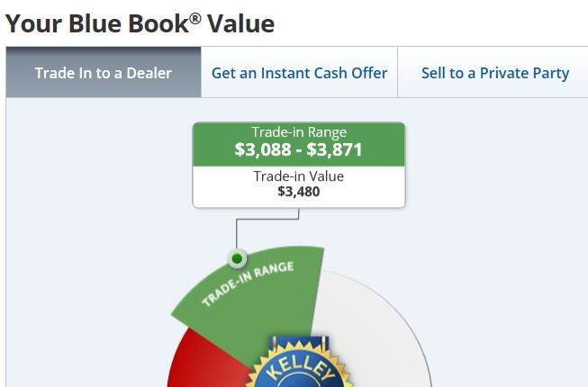The next screen displayed will show the trade-in value to be used in determining eligibility for cash assistance, medical assistance, and food stamp benefits.
2. When verifying the resource value of the nonexempt vehicle, print the last screen, “Your Blue Book Value” and file in the case record for documentation purposes.

P-4