DCF - Install ImageNow upgrade to Perceptive Content

Verify the desktop icon you see says “ImageNow”
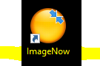

If it does – use the start menu to search for Software Center as shown below:
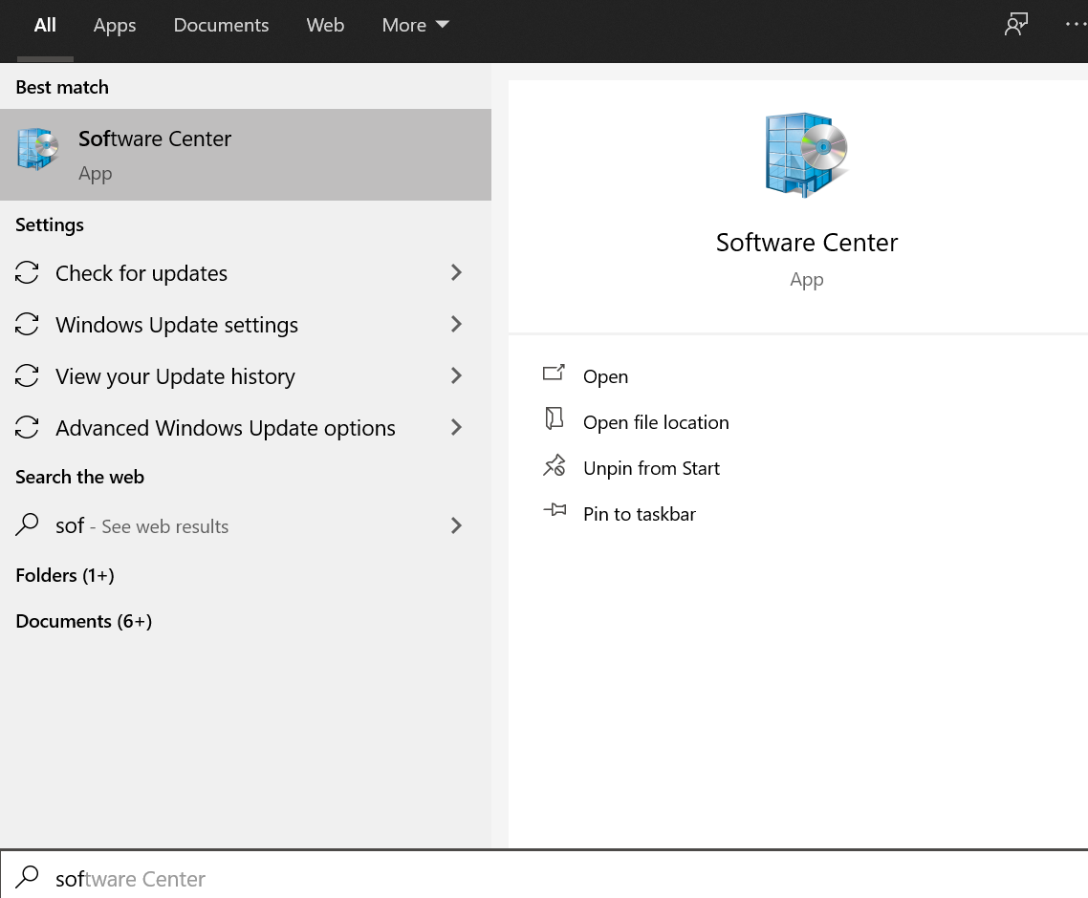

Click to open the Software Center – locate the Perceptive with KEES software icon (your software center will have different software listed, but you only need to find the Perceptive with KEES software shown below):
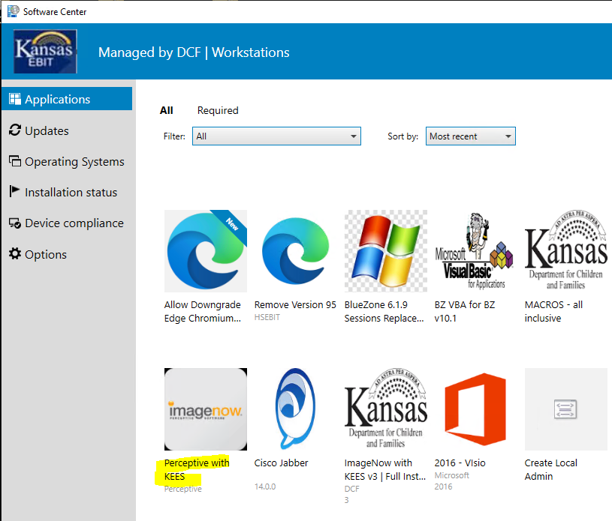

Click on the Perceptive with KEES icon to open it – then click the Install button and wait for the software to install: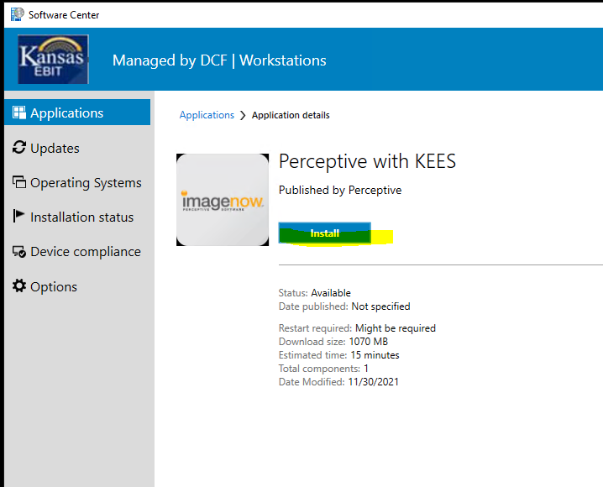

You will see windows pop up and close themselves out while the software is installing, this is normal. It will take approximately 15 minutes to download and install
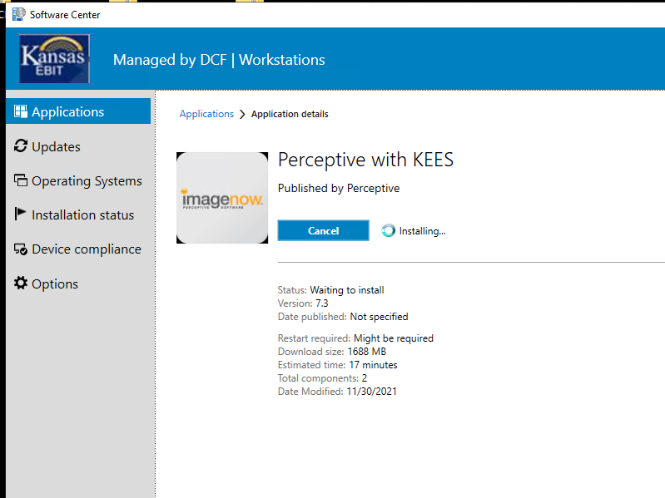

Once you see the “Install” button change to “Uninstall” and a new button “Repair” appear – it is complete, and you may close Software Center.
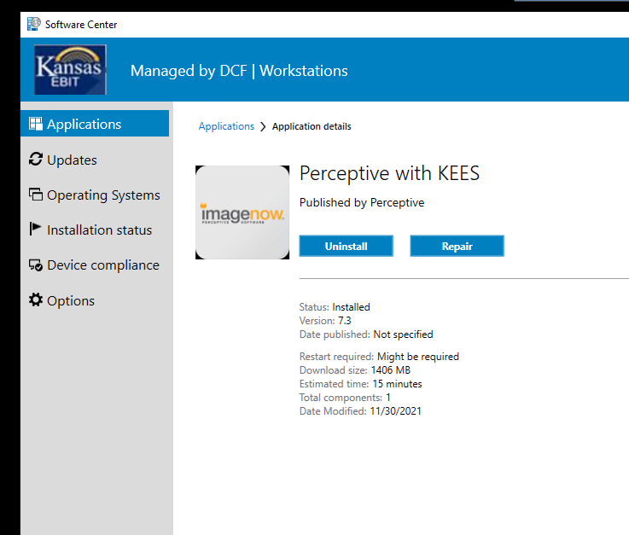

Once complete, you may close Software Center. Click to open the Perceptive Content icon on your desktop and verify the following screens:
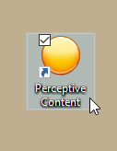

Click Connection Profiles
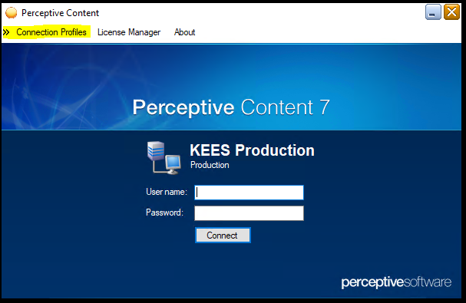

Then at the bottom of the pop-out menu, click Edit Connection Profiles:
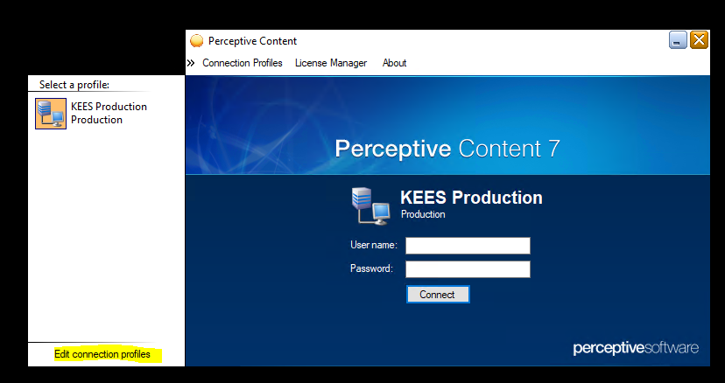

Highlight KEES Production and click “Modify” – verify the information is as shown below:
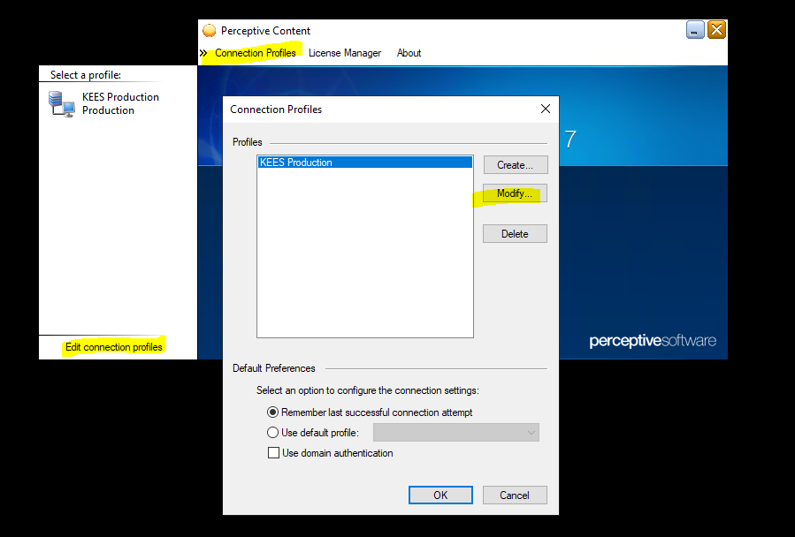
On the 2nd pop-up window you will see the following information
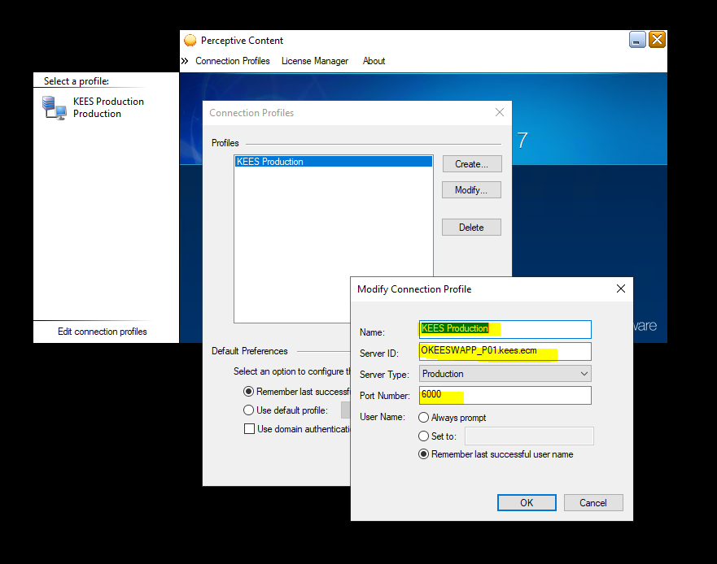
Name: KEES Production
Server ID: OKEESWAPP_P01.kees.ecm
Port Number: 6000
Click OK, then OK again to close those open pop-out windows and log into Perceptive Content 7

If you have any problems with this installation and/or instructions, please send a ticket to EBITSM@ks.gov and we will get with you to assist.

