Searching for SSP Applications in ImageNow

- Click on the documents button from the ImageNow toolbar to launch the ImageNow Explorer


- On the left-hand side under ‘Views’ there will be a list of ImageNow drawers you can access. Click on ‘KEES SSP Documents’
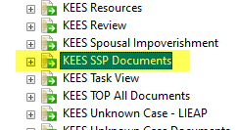
- Once you have clicked on the drawer your quick search will change at the top and should be defaulted to ‘Case Number/ SSP App. ID”
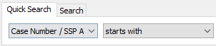
- Type in the SSP App ID in the search field and click ‘Go’. If there is a document with that App ID it should appear.

Searching for Paper Applications in ImageNow

- Click on the documents button from the ImageNow toolbar to launch the ImageNow Explorer

- On the left-hand side under ‘Views’ there will be a list of ImageNow drawers you can access. Click on ‘KEES Registration Documents’
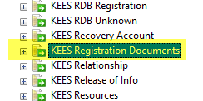
- Once you have clicked on the drawer your quick search will change at the top and should be defaulted to ‘Application ID”

- Paste the IN Application ID that you have copied from Task Inventory in the search field and click ‘Go’. If there is a document with that App ID it should appear.

